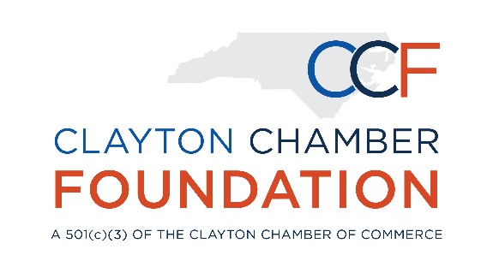
SCHOLARSHIP ESTABLISHMENT FORM

United Community Bank (UCB) First Responders Scholarship Fund

The Clayton Chamber of Commerce and the Clayton Chamber Foundation are dedicated to the educational success of our public servants. Through the United Community Bank (UCB) First Responders Scholarship Fund, eligible first responders can receive up to $1,000 for educational expenses (including books, fees, registration, and materials).

Eligible Professions in Johnston County, NC
- EMT/EMS Personnel

Eligible Professions in Town of Clayton, NC
- Fire Department
- Police Department

Program Description

The purpose of the scholarship fund is to support efforts of The Town of Clayton and Johnston County, North Carolina to expand recruitment, improve training, and provide additional professional development and support to first responders in our community.

All Clayton and Johnston County, North Carolina first responders are eligible to apply. “First responder” means law enforcement officers, firefighters, emergency medical technicians (EMT) and paramedics.

Applications will be accepted beginning in January. Deadline to apply is April 15, and those selected will be notified on May 1.

Details
- Not to exceed $1,000 – including books, fees, and materials
- Must be used for expenses not covered by the entity’s professional development budget
- Online application must be completed
- Letter of recommendation required from chief reporting officer (upload with application)

Signature

My signature confirms the information provided on this form is accurate and represents my/my organization’s scholarship preferences.

Signature Title Date

